Name: Date: 2nd period
Biogeochemical Cycle Notes
Carbon Cycle

Where does a tree get 95% of its mass that makes it grow into a tree?

Photosynthesis: process that uses __________________________ from the sun to convert ____________________________________________ into ________________________________
Cellular respiration: process that breaks down ___________________________ and _____________________________ CO₂ into the air

Decomposition: process by which ______________________________ organisms (living things) are __________________________________________ Ex) _________________________ Decomposition
Combustion: process of __________________________________________________________________________ that releases _______________________________________________ into the atmosphere
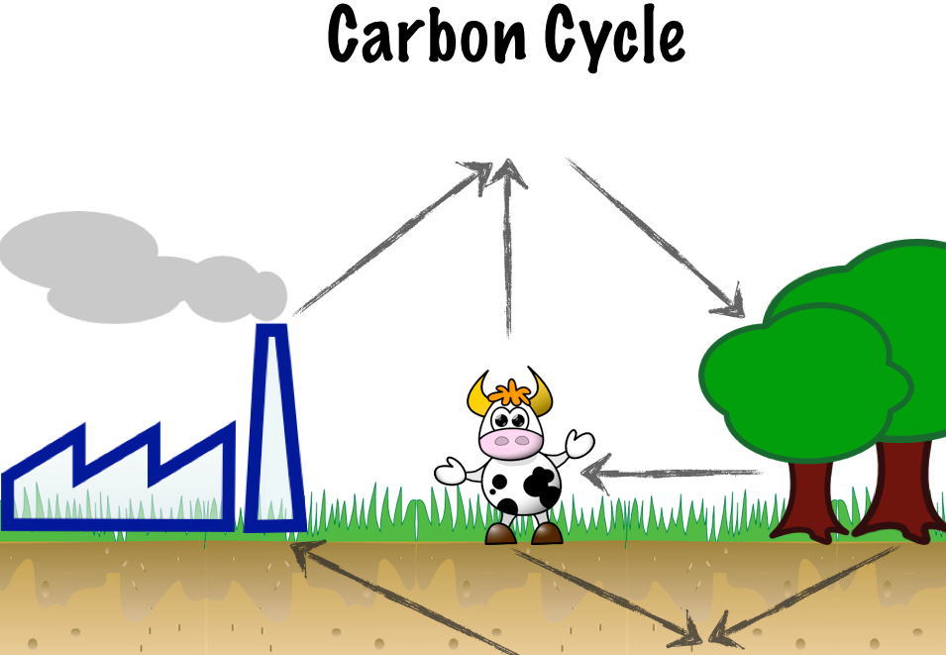

- Atmospheric Carbon (C), from CO₂ is available for plants
- Photosynthesis – plant cells take in CO₂ during photosynthesis to make carbohydrates (sugar), C is now part of the tree and grass
- Eating – animals consume plants (carbohydrates), C is now in cow
- Cellular Respiration – cow cells breaks down carbohydrates for energy and cow exhales CO₂
- Decomposition – dead plants and animals are broken down and in millions of years become fuel
- Combustion – humans burn fossil fuel (oil, gas, coal) for energy and CO₂ goes back into atmosphere
Oxygen Cycle

Photosynthesis: plants give off _____________________ after they break down water to make carbohydrates
Cellular respiration: process that requires ___________________ to ________________ down ________________________
Ozone (O₃): some oxygen moves to the upper atmosphere to protect us from the sun’s radiation
Metal Oxides: most of the earth’s oxygen is stored as metal oxides in the earth’s __________________________

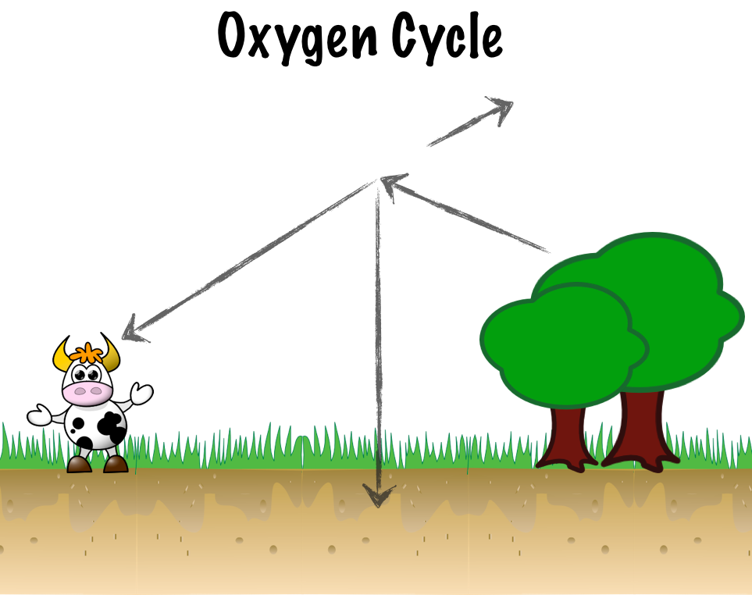

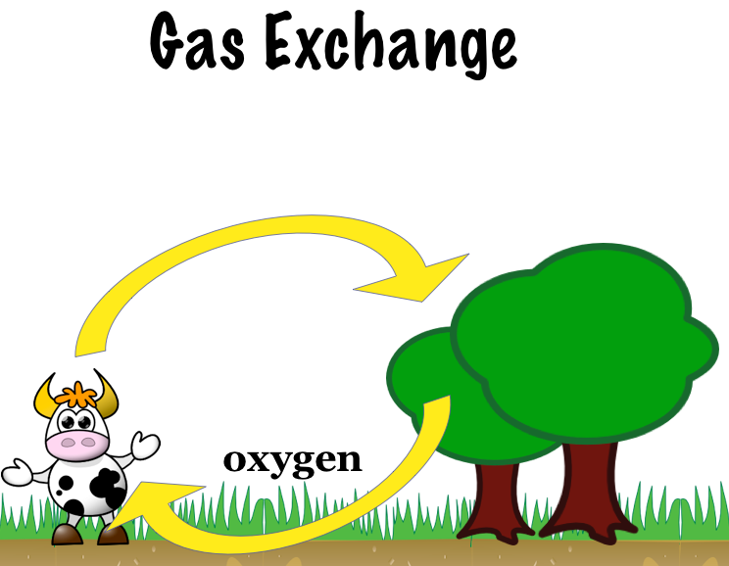
1. By which process do producers release oxygen into the atmosphere?

2. By which process do organisms exhale carbon dioxide into the atmosphere?

3. If the producers (plants) on earth became extinct, what would happen to the consumers (animals)?

